

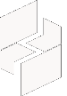

MICROSOFT ARCHITECTURE BEST PRACTICE FOR AI BUSINESS PROCESS
USECASE: ORDER FORECASTING

Document Title | Microsoft Cloud Center of Excellence Overview
Presales/Technical Head | Tushar Mehrotra/Rohit Pandey
CCoE Lead | Ravishankar N
Creation Date | 8th October 2025
Version | Description | Modified by | Date | Approved by | Date
1 | Draft architecture baseline for review | Sharmila Devi K | 08/10/2025 | Ravi Shankar | 08/10/2025
Contents

1. Executive Summary 3
2. Scope and Applicability 3
3. Business Scenario Overview 4
4. Reference Architecture Overview 4
4.1 Architecture Description 4
5. Logical Architecture Components 5
5.1 Data Sources 5
5.2 Data Ingestion Layer 5
5.3 Data Staging & Feature Engineering 5
5.4 Model Training 6
5.5 Model Deployment & Inference 6
5.6 Analytics & Consumption 6
6. Architectural Best Practices 7
6.1 Azure Well-Architected Framework Alignment 7
6.2 Governance & Azure Landing Zone 7
7. Cloud Center of Excellence Enablement Model 7
8. Reusability and Scalability 8
9. Conclusion 8

AI TO FORECAST CUSTOMER ORDERS

Executive Summary
This document defines the standard Cloud Center of Excellence (CoE) reference architecture and architectural best practices for delivering AI-driven next-order forecasting solutions using Microsoft Azure.
The purpose of this document is to:
- Provide a repeatable, standardized architecture
- Support reseller enablement and customer delivery
- Ensure alignment with Microsoft Azure Well-Architected Framework and Cloud Adoption Framework
- Serve as audit-ready evidence for the Microsoft Frontier Distributor designation (Section 3.1.1 – Cloud Center of Excellence)
This reference architecture is derived from Microsoft’s official guidance on Next-Order Forecasting and AI solution design on Azure.

Scope and Applicability
This reference architecture applies to:
- CSP distributors enabling reseller-led AI solutions
- SMB, Mid-Market, and Enterprise customers
- AI Business Process and Cloud AI Platform workloads
- Forecasting, demand prediction, and inventory optimization scenarios
The architecture can be adapted for:
- Single-tenant or multi-tenant reseller delivery
- Through-channel or co-delivery engagements
- Regional deployments aligned with CSP authorizations

Business Scenario Overview
Next-order forecasting enables organizations to predict future customer order quantities at a SKU or product level by leveraging historical transaction data and external signals.
Business Benefits
- Improved inventory planning
- Reduced over-stocking and stock-outs
- Increased upsell and cross-sell opportunities
- Data-driven renewal and consumption strategies
Typical Use Cases
- Distributor inventory forecasting
- Reseller sales recommendations
- Customer demand prediction
- AI-driven CRM and ERP insights

Reference Architecture Overview

4.1 Architecture Description
The solution follows Microsoft’s seven-stage AI forecasting architecture, covering:
- Data Sources
- Data Ingestion
- Data Staging & Preparation
- Model Training
- Model Deployment & Inference
- Analytical Storage
- Business Application & Reporting
This architecture supports scalable, secure, and governed AI workloads.
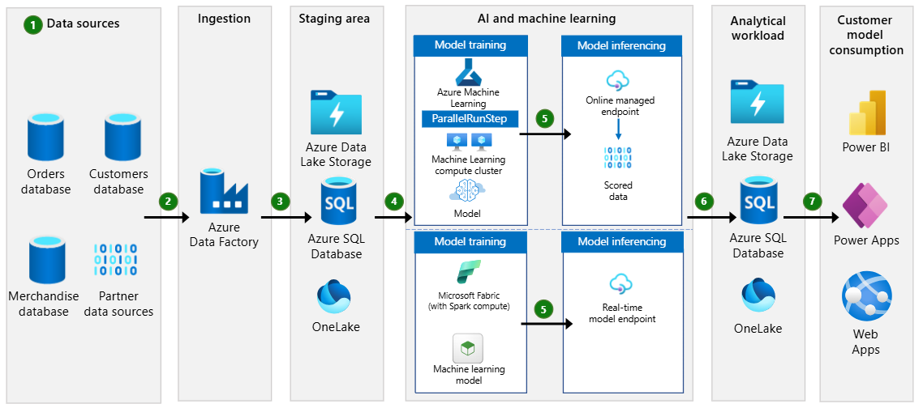

Logical Architecture Components

5.1 Data Sources
- Customer master data
- Order history databases
- Product and SKU catalogs
- External data sources (holidays, weather, market indicators)

5.2 Data Ingestion Layer
- Azure Data Factory
- Scheduled and event-based pipelines
- Data validation and schema enforcement
Best Practice
- Maintain metadata tagging for lineage and governance
- Centralize ingestion patterns for reuse by resellers

5.3 Data Staging & Feature Engineering
- Azure Data Lake Storage Gen2
- Azure SQL Database or Microsoft Fabric (OneLake)
- Spark-based feature processing
Best Practice
- Separate raw, curated, and feature datasets
- Enable role-based access to sensitive datasets

5.4 Model Training
- Azure Machine Learning
- Automated ML (AutoML) forecasting
- Parallel training for multiple SKUs/customers
Best Practice
- Use versioned datasets and experiments
- Enable reproducibility and audit traceability

5.5 Model Deployment & Inference
- Azure ML Managed Online Endpoints
- Batch and real-time inferencing
- Versioned model promotion
Best Practice
- Enforce model approval workflows
- Implement rollback strategies

5.6 Analytics & Consumption
- Microsoft Fabric
- Power BI dashboards
- Power Apps or custom web applications
Best Practice
- Role-based dashboards
- Separate operational and executive views

Architectural Best Practices

6.1 Azure Well-Architected Framework Alignment
Pillar | Implementation Approach
Reliability | Zone-redundant services, backup policies
Security | Zero-Trust, RBAC, Defender for Cloud
Performance | Autoscaling compute, optimized storage
Cost Optimization | AutoML budgets, consumption monitoring
Operational Excellence | IaC, monitoring, CI/CD pipelines

6.2 Governance & Azure Landing Zone
- Standardized Azure Landing Zone (ALZ)
- Centralized policy enforcement using Azure Policy
- Identity management with Microsoft Entra ID
- Logging and monitoring via Azure Monitor
Best Practice
- All AI workloads must deploy into a governed landing zone
- Policies applied at management group level

Cloud Center of Excellence Enablement Model
The Cloud CoE maintains and governs:
- Reference architectures
- Solution playbooks
- Reusable Infrastructure-as-Code modules
- Security and compliance guardrails
- Technical skilling content for resellers
- Delivery readiness checklists
All assets are version-controlled and reviewed quarterly.

Reusability and Scalability
This reference architecture is designed to be:
- Reusable across regions
- Adaptable to customer size
- Compatible with through-channel delivery models
- Extensible for advanced AI use cases

Conclusion
This Cloud Center of Excellence reference architecture establishes a consistent, Microsoft-aligned, and audit-ready foundation for AI-driven next-order forecasting solutions on Azure.
It ensures scalability, security, governance, and repeatability across the distributor’s reseller ecosystem.

